28th June 2022

Dear Parents and Carers

On Friday 1st July, from 2.30pm, The Friends of Redhill will be holding a second-hand uniform sale on the big playground.

This is your opportunity to buy school polo shirts, jumpers, cardigans, PE hoodies and PE tops.

Please see the price list below.

We will be able to accept cash and card payments for these items.

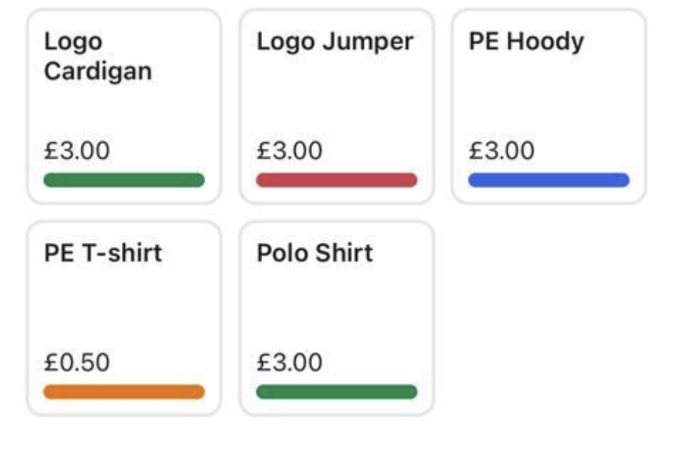
We look forward to seeing you there.

Kind regards

Pru McCarney
Chair of the Friends of Redhill Academy

